Gergerger

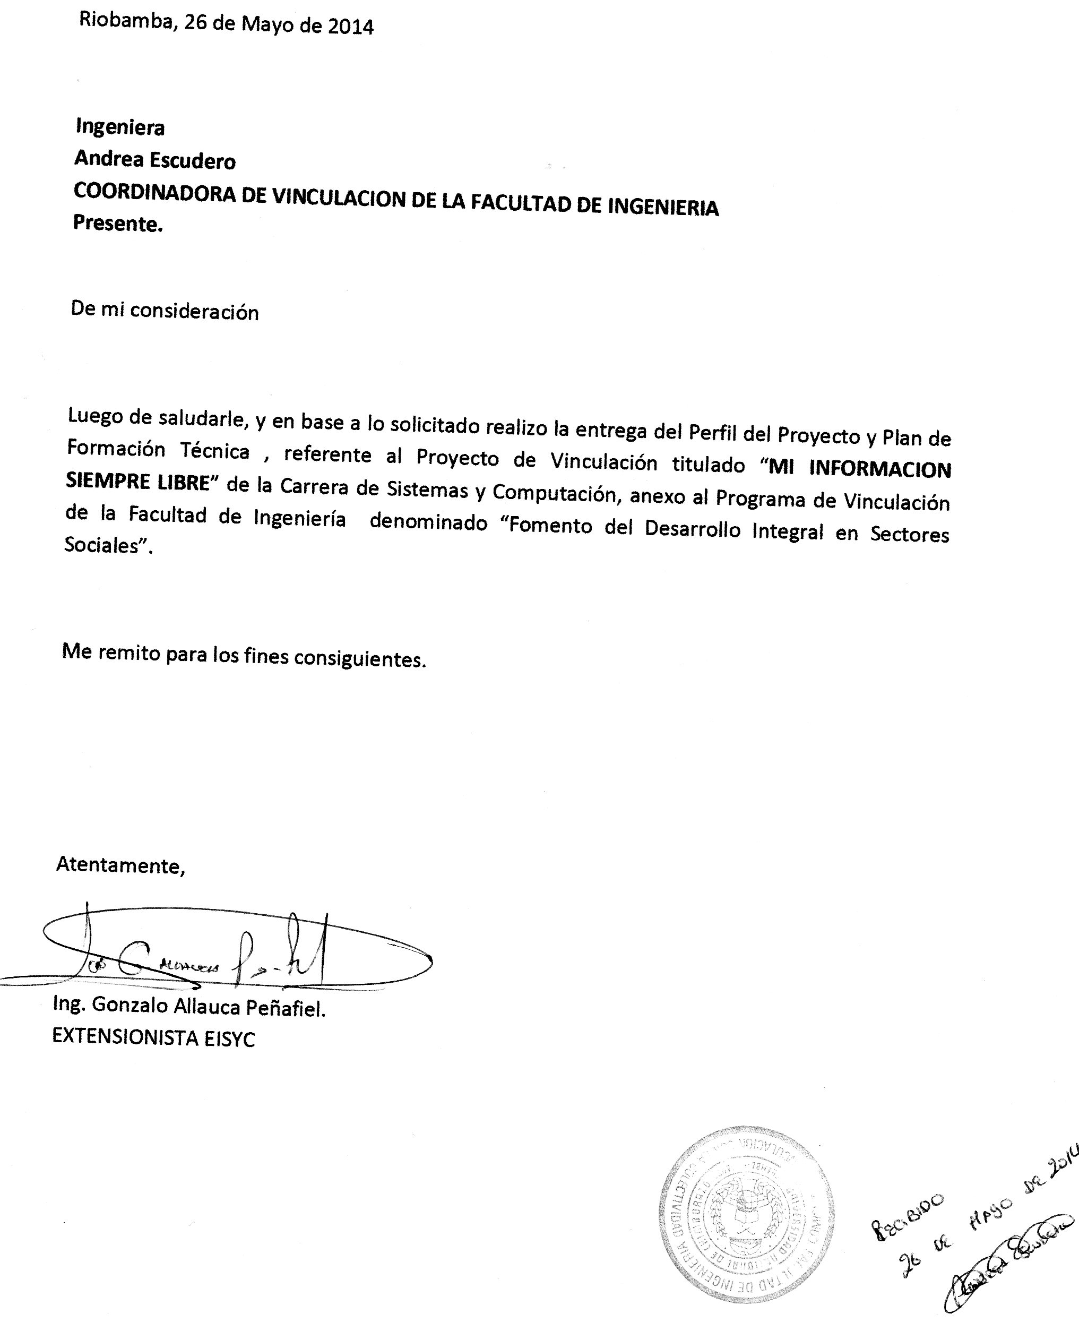

Kmlmlñ
E12d | |
cfwrfwe

